**Contributions and Technical Artefacts**

**Frontend Design**

The frontend design was vital since it connected users to the AI-powered vulnerability detection system. To improve user experience, I created responsive, user-friendly, and attractive web pages.

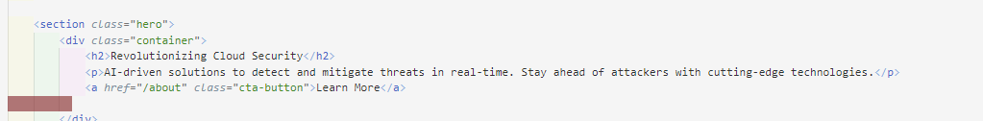

Figure Hero Section

Figure Features Section

Figure Navigator and Footer

Figure Footer design



Figure Mission Section

Figure Team Section

Figure Threat Detection Section



Figure Displaying predicted result

1. **Development of Responsive Web Pages:**
   * I created four main web pages—Home, About and Admin —using HTML and CSS, ensuring a cohesive design across the application (Figures 1–8).
   * **Home Page:**
     + HTML and CSS were used to create four web pages (Home, About, and Admin) for a consistent application design (Figures 1-8).
     + Designing a homepage hero section with a stunning background and strong call-to-action button (Figure 1).
     + In a grid format, the system's benefits were clear (Figure 2).
     + Added navigation links to header and footer for smooth page transitions (Figures 3 and 4).
   * **About Page:**
     + The About Page describes the project's goals.
     + Team details, including photos and roles, were arranged for readability (Figures 5 and 6).
   * **Admin Page:**
     + On the Admin Page, a dynamic form was created for threat detection, allowing users to input textual data for analysis (refer to Figure 7).
     + Dynamic prediction results were shown underneath the form to promote engagement (Figure 8).
2. **Ensuring Cross-Browser Compatibility:**
   * To ensure consistent functionality and design across browsers, I tested all web pages on Chrome, Firefox, Edge, and Safari.
   * Changed CSS attributes and vendor prefixes to fix browser-specific rendering issues.
3. **Responsiveness Across Devices:**
   * CSS media queries optimise layout for computers, tablets, and phones.
   * Make buttons and forms touch-friendly for smaller screens.
4. **Challenges and Solutions:**
   * **Challenge:** Aesthetics, usability, and fast loading.
   * **Solution:** Reduced heavy elements like high-resolution images and used efficient CSS to improve performance.

**Model Evaluation and Comparison**

Evaluation and comparison of machine learning models were needed to identify the best deployment algorithm. My contributions were model performance metrics analysis and presentation.

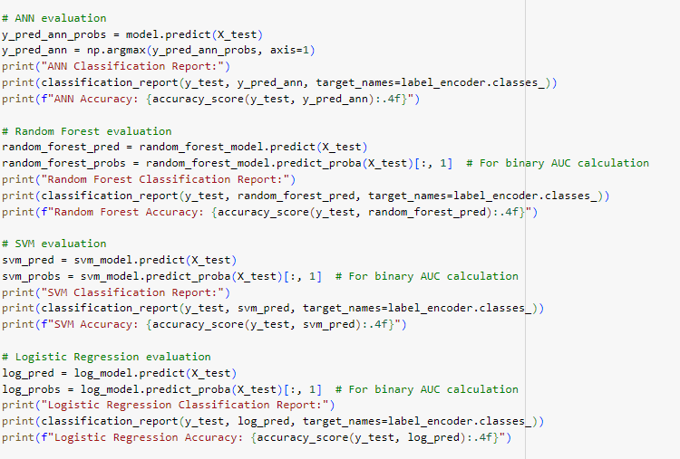

Figure Model Evaluation

Figure Model Evaluation Results

Figure Comparison of Performance Metrics

1. **Comprehensive Evaluation of Models:**
   * Assess Random Forest, ANN, SVM, and Logistic Regression using accuracy, precision, recall, F1-score, and AUC (Figures 9-11).
   * **Steps in Evaluation:**
   * Created detailed categorisation reports for each model, exhibiting performance across classes.
   * Used AUC values to evaluate each model's binary classification performance.
   * Analysed accuracy, recall, and F1-scores to find models that effectively handled imbalanced datasets for rare and frequent classes.
2. **Comparison of Model Performance:**
   * Comparing Model Performance: Bar charts simplify performance comparisons (Figure 11).
   * - While ANN models performed well, Random Forest was more interpretable and balanced.
   * Explained dataset complexity and class imbalance limits of Logistic Regression and SVM.
3. **Impact of Evaluation:**
   * The team chose the Random Forest model based on my evaluation, ensuring accuracy and efficiency.
4. **Challenges and Solutions:**
   * **Challenge:** Assessing unbalanced datasets fairly.
   * **Solution:** Prioritised minority class indicators like recall and F1-score over accuracy, which can be misleading in unbalanced situations.

**Testing and Deployment**

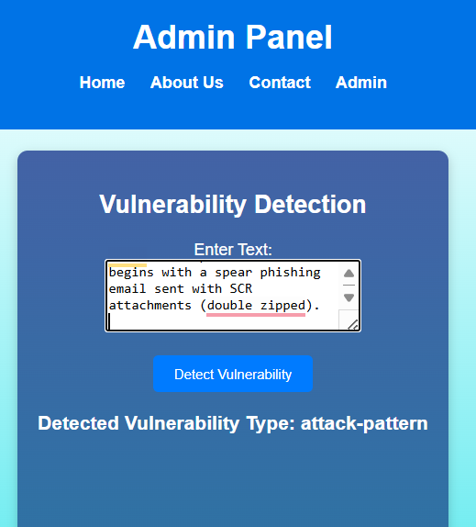

Figure Back End Testing

Testing and deployment were necessary to verify the app's real-world functioning and reliability.

1. **Functional Testing:**
   * End-to-end web page testing to ensure functionality (Figure 12).
   * **Verified the following:**
     + Users navigated to right pages without errors using navigation links.
     + Forms, including Admin forms, processed inputs and displayed proper validation signals.
     + Users could dynamically examine prediction results on the Admin page after entering data.
2. **Backend Testing:**
   * Examined Flask-machine learning model integration.
   * Simulated various input scenarios, including:
     + Simulations had valid inputs and reliable predictions for well-formed data.
     + Resilience assessment for handling unexpected or faulty inputs.
3. **Load Testing:**
   * Simulated heavy traffic with multiple people accessing the Admin page and submitting forms.
   * Made Flask installations more load-tolerant without compromising performance.
4. **Bug Identification and Resolution:**
   * Bug Identification and Resolution:
   * **Input validation:** Addressed input validation issues: Sanitised special characters and formats before processing.
   * **Backend errors:** Server faults are now handled by the backend, which shows user-friendly messages.
5. **Real-World Testing and Scalability:**
   * Real-World Testing and Scalability: Recorded application performance when deployed.
   * Scaled the application for user and data growth.
6. **Challenges and Solutions:**
   * **Challenge:** High-traffic scalability.
   * **Solution:** Stress testing and improving server settings like thread pooling and asynchronous request handling solved the problem.

**Technical Artefacts**

Key objects from my contributions helped the project succeed:

1. **HTML/CSS Templates:**

* Made modular, reusable templates for all web pages.
* Features include:
  + Modern, clean designs for enhanced user engagement.
  + Employed responsive layouts for different screen sizes and devices.
* **Impact:** These templates made the software look professional, enhancing user trust and satisfaction.

1. **Evaluation Reports:**

* Model classification reports with precision, recall, F1-score, and accuracy.
* Bar charts were used to compare model performance and choose the best algorithm.
* Data-driven model selection was enabled by reports.

1. **Testing Framework:**

* Created a comprehensive functional testing framework to verify application component usability and accuracy.
* Conducted backend testing to ensure smooth integration of machine learning model and Flask application.
* Load testing assessed system scalability and robustness in high-traffic areas.
* **Impact:** This framework made the app reliable, scalable, and deployable.

**Challenges and Impact**

I overcame project challenges:

1. **Balancing Aesthetics and Functionality:**

* **Challenge:** Creating a beautiful frontend without sacrificing performance or usability.
* **Solution:** The solution balances aesthetics and speed with lightweight CSS and optimal assets.

1. **Handling Edge-Case Inputs:**

* **Challenge:** Handling edge-case inputs requires the application to handle unexpected or incorrect user inputs.
* **Solution:** Improved input validation and preparation for data sanitisation.

1. **Scalability:**

* **Challenge:** Managing concurrent users without performance degradation.
* **Solution:** Optimising Flask configurations and testing in high-traffic scenarios solved the problem.

**Impact of Contributions**

* My work resulted in a polished, user-friendly, and stable app: • Improved User Interface: **Engaging User Interface:** Responsive web pages enhanced program accessibility and intuitiveness.
* **Data-Driven Insights:** Evaluation reports provided relevant model performance insights to help the team choose a deployment choice.
* **Robust Application:** The thorough testing infrastructure made the robust application stable and scalable, meeting all project goals.